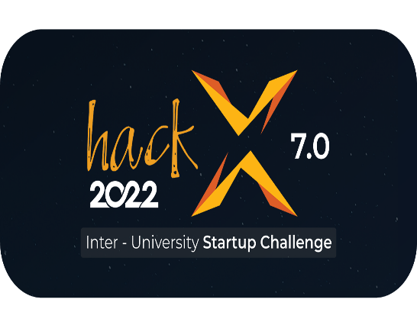

|  |  |
| --- | --- |
| **Team Name** | NICK |
| **University** | University of Ruhuna |
| **Product Name** | Medibell |
| **Category** | Medical |

|  |
| --- |
| **Problem Definition, Analysis and the Solution** |

**Problem – Forgetfulness of patients or caregivers about the medical treatments and medicine dosage in possession.**

**Solution – Medicine Reminder Application which focuses to help the customer to fulfill regular medicine requirements**

We encountered from our experience that inability to regulating the process of taking multiple medicine at correct meal is a common problem among patients and caregivers. The majority of the patients and caregivers do below mistakes because of this issue.

* Miss to get medicine on time
* Forget to purchase and refill medications after the season was finished.
* Miss to meet doctor the exact date
* Some medicals reports are lost at certain time

Therefore, these mistakes lead to the huge risk of living or live or death situation in customer.. Now, this is no longer an issue because our product will address this problem.

The product is significant as a solution since it is a mobile app that serves as a caretaker and a reminder. The product may be used without facing any cumbersome registration process because the main interacting interface between customer and developer exists via Mobile application which designed for user friendly context. As the maintenance and the initial cost is low product is financially beneficial. As the main concern is to remind the individual, the application reminds the relevant medical treatment and updates dosage-related details through continuous updating of the system database. This helps to maintain medical treatment progress effectively and to maintain the dosage of medicines in possession properly.

|  |
| --- |
| **Product overview and Uniqueness of the Product** |

**Description about the product**

We are introducing an application for patients who don't remember the exact time for their medication and also for those who have multiple medications per day or frequently. This app is also useful for the caregiver, and the app itself acts as a caregiver for the patient. This is an application with passcode protection. Furthermore, the app can be used by multiple users that can generate the outputs for each patient separately.

**Key features**

There are 6 main features in this app.

1. **Remind them of their upcoming appointment's date** **(Med Calendar)** - The app sends a reminder for a patient's upcoming clinic appointment.
2. **Bring up the precise timing of the drug** **(Bell)** - The app serves as a reminder to remind you to take the medication. For individuals who are busy or have trouble keeping track of time, it is important. The app will sound an alert when it's time to take your medication.
3. **The dosage of the drug as summarized and preview** **(Medication Box)** - The total quantity of untaken medications is always given as a preview.
4. **The number of days remaining for each medication** **(refill)** - The app provides a countdown to the end of each medicine in days.
5. **The method to save all records and reports** **(Reports)** - This is a unique function of the app. The relevant report can be saved in the app as a pdf file. The file will be stored on the drive after being converted from jpg or png to pdf.
6. **A detailed description of each drug** - A brief summary of each medicine in any language will be provided by the app.

**Similar products in the market**

* Medisafe Pill and Med Reminder - Pill reminder and alarm for all medication needs
* Pill Reminder and Medication Tracker - A medication alarm reminder
* Medication Reminder and Tracker - A medication alarm reminder, and refill stock of pills before they run out.

|  |
| --- |
| **Business Model and Marketing Plan** |

This app is going to be fully depend on the content of the app. There for the user is allowed to use this app for 14 days to try the app. After 14 days user is requested to review the app and user has to pay to app to use it further. Then the app can be improved according to the user reviews with updates and as well as user has a chance to use and purchase the app. As well as by the reviews app can be distributed easily among users by using user recommendations reviews. Further as business strategies we are hoping to connect the features like google calendar then we can expect them as a sponsorship and also hoping to Identify and research the most influential blogs, groups, forums, and websites where targeted audience visits in order to acquire and reach users. Promote on social platforms such as Facebook, Instagram, Twitter by demonstrating the vales and the purpose of the product via adds is a marketing strategy that we intendent to follow.

|  |
| --- |
| **Technical Overview and Implementation** |

First, we drew the CI/CD pipeline to recognize the main functions of the app. Based on that we decided to use Flutter to design UI as it is very flexible. As we have to maintain a database inside the app, we decided to use Firebase for that. Further we have to give remainders through the app. Therefore, APIs of google calendar is expected to be used inside the app. In our CI/CD pipeline we are going to implement as Self-hosted CI/CD process. In our CI/CD pipeline we are going to implement as Self-hosted CI/CD process. Further considering our pipeline , we are going to implement as cloud-based CI/CD process.

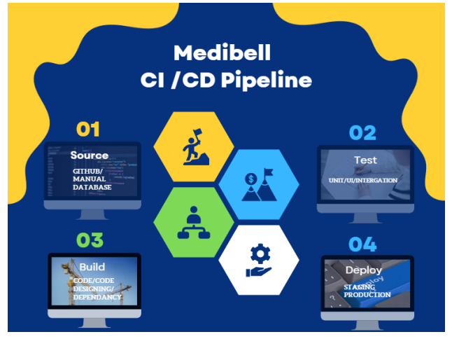

Figure 1 : Medibell CI / CD Pipeline

|  |
| --- |
| **User Scenario** |

Usually, grandparents instruct grandchildren or their children to bring their medications the day before or few days before their end date. Due to busy schedules of grandchildren or children sometime they forget to bring the medicines. Additionally, forget to remind their grandparents that they need to take a few medications on time.

Many persons who suffer from chronic diseases, injuries, or impairments are affected by this issue. They failed to get their medications on time, and others who are responsible for caring for them also struggle with this issue.

If some services could be offered through a smartphone application, it would make it easier and healthier for many people to continue their way of life. We aim to construct it such that it fully covers your application for medical aid, unlike other reminder apps. Our target audience will know about a new mobile app called “Medibell”.

|  |
| --- |
| **Team Details** |



Name - Chathusha Ariyasinghe

NIC No - 200011902049

Email - chathusha2000@gmail.com

Mobile No - 0775146796

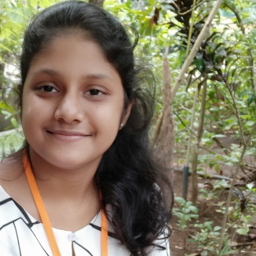

Name - Taneesha Iyenshi

NIC No - 200083403700

Email - iyenshiaut@gmail.com

Mobile No - 0764709893

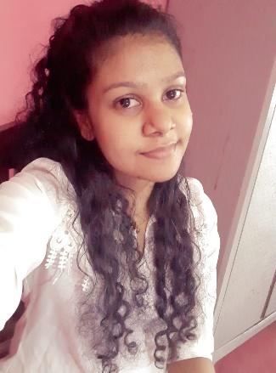

Name - Kalangi Jayakody

NIC No - 200077602335

Email - thathsarakalangi@gmail.com

Mobile No - 0711530365



Name - Nadun Dasantha

NIC No - 200013400196

Email - nadundasantha10@gmail.com

Mobile No - 0713931469